|  |  |  |  |  |
| --- | --- | --- | --- | --- |
|  |  | | | l&h - logo, black and white |
| Journal of Applied Nonlinear Dynamics | | |
| https://lhscientificpublishing.com/Journals/JAND-Default.aspx | | |
| Influence of Embedded Material on Natural Frequencies of Double Segment Rotating Disk | | | | |
| Ehsan Sarfaraz[1]† and Hamid R. Hamidzadeh | | | | |
| Department of Mechanical and Manufacturing Engineering, Tennessee State University, Nashville, TN 37209, USA | | | | |
| **Submission Info**  Communicated by Valentin Afraimovich | |  | **Abstract**  An analytical method is presented to determine the effect of adding different materials at one of the edges of an annular rotating disk on its in-plane natural frequencies and critical speeds. The proposed analysis is based on the linear in-plane free vibration of a compound disk with material discontinuity, by adopting the two-dimensional plane stress theory. The frequency equation was achieved by satisfying the compatibilities of the displacements and stresses at the interfaces of the different segments. The materials used in each segments of the disk are assumed to be homogenous, elastic, and isotropic. Furthermore, the annular disk is considered to be clamped at the inner side and free at the outer edge with a radius ratio of 0.3, and rotates with a constant angular speed. The variation of non-dimensional natural frequencies in fixed coordinates for different modes and different segment radiuses at the inner or outer side with respect to speed of rotation are computed. Presented results indicated that by adding additional segment, undesirable natural frequencies of the rotating disk can be modified to be within the acceptable range.  © 2012 L&H Scientific Publishing, LLC. All rights reserved. | |
| **Keywords**  In-Plane  Free vibration  Rotating disks  Compound disks  Annular thin disks  Mode shapes  Critical speeds  Natural frequencies  Medium with discontinuity | |

**1 Introduction**

Rotating annular disks are commonly used in a wide variety of engineering applications including space structures, circular saw blades, electro-mechanical components, optical memory disks (CD and DVD), and rotating machinery. Nevertheless, the in-plane vibration of rotating disks has received relatively little attention in the past and has started gaining increasing attention in recent years. In order to reflect the importance of the in-plane modes of vibrating for rotating disk, a few investigators have contributed to the better understanding of various practical problems. The problems of in-plane vibration of rotating disks have only been addressed in a few studies. Bhuta and Jones [1] investigated a solution to the axisymmetric in-plane vibrations of a thin rotating circular disk for some specific modes and they concluded that in general the effect of rotation is to lower the natural frequencies for the modes that they considered. Burdess et al. [2] presented generalized solution by implementing Lame's potentials to consider asymmetric in-plane vibrations. Their investigation indicated that unlike the axisymmetric modes, the rotation cause the natural frequencies to yield two distinct values. Thus, the effect of rotational speed on forward and backward traveling waves for a mode with two nodal diameters was presented for a solid disk with free outer edge. Chen and Jhu [3] studied the divergence instability of fixed-free spinning annular disks, and investigated the influence of radius ratio on the natural frequencies and critical speeds of the disks. Their study concluded that the critical speeds of in-plane modes with different nodal diameters approached a single asymptotic value as the nodal diameter increases. This value was determined to be independent of the radius ratio, but dependent on Poisson ratio. Hamidzadeh [4] analyzed the same problem where the equations of motion were represented in terms of the dilatation and the elastic rotation. Hamidzadeh and Dehgani [5] studied the effect of rotational speed and radius ratio on the natural frequency and elastic stability of fixed-free rotating disks. He also developed an analytical solution for the in-plane vibration of spinning rings [6].

Moreover, Hamidzadeh and Karim [7] presented an analytical method for the determination of vibration characteristics of high speed double-segment rotating disks. He also presented non-dimensional natural frequency for fixed-free rotating disks for several modes and wide range of speeds [8]. Deshpande and Mote [9] studied the stability of a spinning thin disk using a nonlinear strain in order to account changes in stiffness of the disk due to its rotation. Their study suggested that the critical speeds were different using the linear strain assumption. In their work, they obtained the axisymmetric radial expansion and the associated additional stiffening effects.

The main scope of this study is to modify an undesirable existing natural frequency or a critical speed by attaching different materials at one of the edges. The investigation presented in this article will be confined to the linear in-plane vibration of a thin rotating disk with two segments. The disk consists of one main section and one segment with discontinuity in the added material on one of the edges of the disk. The disks are assumed to be clamped at the inner edge and free at the outer side. The applications of the present study can be used to enhance the current design of computer disks by allowing higher operating speeds of rotation. The governing equation of motion is derived using Hamidzadeh’s approach [8]. The general solution is developed to obtain the displacements and stresses distributions for the discontinuous compound disk. The analysis is conducted to obtain the effect of added segment with higher mass, at the inside or outside edge of the disk, on the natural frequencies and critical speeds.

**2 Development of the Governing Equation**

Typical rotating compound disks are depicted in Figure 1. In general, the disk consists of two segments with different types of materials. However, in this report numerical results are provided for a specification case, where the main part of the disk is assumed to be aluminum with an added a small disk segment of steel at the inner edge of the disk or at the outer edge of the disk. Each part of the disk is assumed to be thin, elastic, isotropic and homogeneous. The rotation speed of the disk is assumed to be constant and the two-dimensional elastodynamic theory is employed to derive the governing equations of motion. Considering the plane stress condition, the equations of motions for a point on the disk in polar coordinates are provided in equation (1).

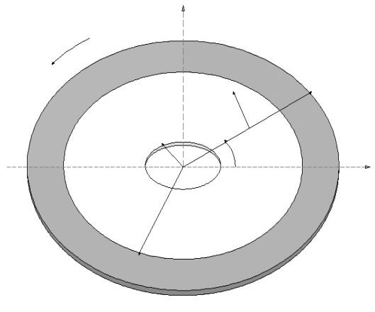

**b**

**a**

**u**

**v**

**c**

**x**

**y**

**II**

**I**

**(c)**

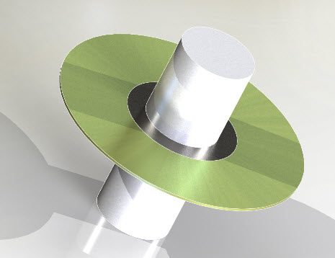

**(b)**

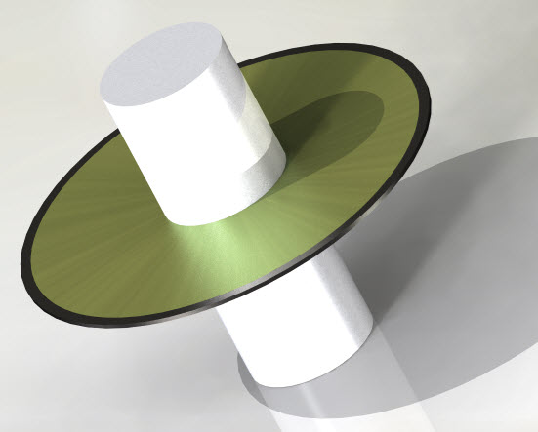

**(a)**

**Fig.1** A compound disk (a) with added segment at the outer edge (b) added segment at the inner edge (c) its coordinates and geometry

 (1)

and the related normal and shear stresses can be written by the following three equations:

 (2)

Using Hooke’s law the strains in terms of plane stresses can be written by the following equations:

(3)

Where is the shear modulus and can be presented in terms of the modulus of Elasticity *E* and the Poisson ratio *υ*

 (4)

Introducing Δ as sum of and and the elastic rotation, they can be presented by the following equations:

 (5)

Solving for direct stresses from equation (3) in terms of Δ and direct strains, then the plane stresses can be written by the following equations:

 (6)

where λ is the Lame’s constant and is defined as:

 (7)

By substituting from equations (6) and (2) into equations (1) and utilizing equations (5) after simplifications they yield:

 (8)

The acceleration of a point on the rotating disk at radius of *r* with radial and tangential displacements of *u* and *v* are determined by differentiating the position vector twice with respect time. Considering that the displaced position vector is

 (9)

its accelerations will be written as:

 (10)

Introducing velocities of radial and shear waves, and , by the following equations

 (11)

and considering that the disk is rotating with a constant angular velocity, thus the angular acceleration would be zero (. Using equations (11) and substituting radial and tangential components of acceleration from equation (10) into equation (8) they become:

(12)

Differentiating the above equations with respect toand and simplifying them they yield the governing equations of motion for the freely rotating annular disk

 (13)

where is the Laplacian operator

 (14)

**3 Modal Stresses and Displacements**

Considering the coupled differential equations presented in equations (13), the following solution can be assumed:

 (15)

Where is a time independent function, and are time dependent functions. The solution of time independent equation is important in determining the steady-state responses of the system and it can be given by:

 (16)

The time dependent equations have a significant role in determining the natural frequencies of the system. For convenience the following non-dimensional parameters are utilized:

 (17)

Substituting modal expression from equation (15) into governing equation (13), the two different ratios of modal elastic rotation to modal dilatation are expressed by the following equations:

 (18)

Where

 (19)

The modal elastic rotation and dilatation then can be presented as combination of first and second kind of the Bessel functions (and):

 (20)

The radial and tangential displacement in terms of time can be presented in the following form

 (21)

Substituting equations (20) and these displacements into equations (12) and rearranging, the result yields the modal solution for the non-dimensional radial and tangential displacements:

 (22)

where prime and double prime (' and ") represent first and second derivatives of the function, and and can be presented by:

 (23)

Similarly, the modal radial and shear stresses can be expressed by the following relations:

 (24)

The non-dimensional modal radial and shear stresses are obtained from equation (6) by substituting from equations (20) and (22), and after simplifications they are presented by

 (25)

Where

 (26)

Using equations (22) and (25), the modal displacements and stresses at any radius for each part of an annular disk can be expressed in the following form:

 (27)

The elements of are expressed in reference [8], these elements are in terms of material properties and Bessel functions of first and second kinds.

**4 Natural Frequency Equations**

To obtain the modal information and natural frequencies of the annular rotating disk, the boundary conditions must be satisfied. To satisfy the boundary conditions and considering the compatibility of the modal displacements and stresses, equation (27) can be written for both disk segments to relate non-dimensional modal vectors for displacements and stresses at boundaries of each disk. This process for the inner disk yields:

 (28)

where index of *I* refers to the inner disk and

 (29)

similarly for the outer disk with different material properties, equation (27) for its inner and outer radius of and can be written as:

 (30)

where index of *II* refers to the outer disk and

 (31)

To unify the dimensionalized vectors andfor each segment the matrix is introduced such that:

 (32)

where

 (33)

Then compatibility of stresses and displacements at for disks *I* and *II* require

 (34)

where

 (35)

For a fixed-free rotating annular disk (clamped at inner edge and free at outer edge) to satisfy the boundary conditions at radiuses and , thus adopting these boundary conditions, equation (34) can be written as:

 (36)

where is a matrix

 (37)

Considering the fixed-free boundary conditions, equation (36) will be reduced to the following expression for determining the inner modal boundary stresses

 (38)

Thus the frequency equation for the compound thin disk can be written as:

 (39)

**4 Discussion and Results**

In this section, natural frequencies, critical speeds, and distribution of stresses and displacements for two different sizes of added disk segments with material discontinuity are presented. The non-dimensional natural frequency for the compound disk is defined as and non-dimensional rotational speed is defined as. The non-dimensional natural frequencies of a compound rotating annular disk for different numbers of nodal diameters and numbers of nodal circles ( versus a wide range of rotating speeds are provided. Computations were performed to determine the effect of the embedded material properties on the variations of non-dimensional natural frequency versus rotating speeds. Table1 shows the material properties for each segment. To verify the validity of the analytical method presented, computed results for and for a fixed-free single disk with radius ratio of 0.2 is compared with those established by Hamidzadeh [8] and Chen and Jhu [3] in figure 2. The comparisons indicate excellent agreement among these results.

**Table 1** Specification of materials

|  |  |  |  |
| --- | --- | --- | --- |
|  | Poisson’s ratio | Density  ) | Young modulus  *)* |
| Aluminum | 0.335 | 2.7 | 69 |
| Stainless Steel | 0.305 | 7.7 | 180 |

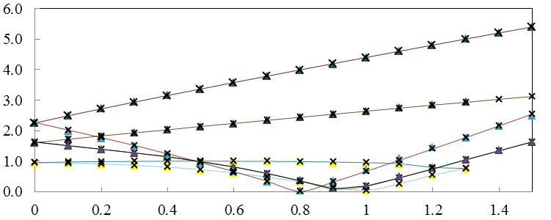

**(0,3)f**

**(0,1)f**

**(0,1)b**

**(0,2)b**

**(0,3)b**

**(0,2)f**

Present

Hamidzadeh [8]

Chen and Jhu [3]



**Non-dimensional natural frequency,**

**Non-dimensional rotational speed,**

**Fig. 2** Comparison of non-dimensional natural frequencies for and with established results

In this study, in addition to analyzing a single rotating disk two other cases were considered by adding a small steel segment either to the inner or to the outer edges of the main aluminum disk. Case I is for a single aluminum disk, case II is for a compound disk with added steel segment at the outer side of the main aluminum disk, and case III is for the steel segment added at the inner side of the of the main disk. To determine the effects of outer or inner added segment on the non-dimensional natural frequencies and the respective modal displacements and stresses, they were computed for two different values of and. Where and. The distributions of non-dimensional modal displacements and stresses for three cases of single and compound disks with the same equivalent radius ratio of,, and for the wave numbers and are presented in figure 3. This figure demonstrates that radiuses of the three nodal circles are slightly increased for case II. The same is also true for the first two inner nodal circles for case III. Furthermore, it is observed that the non-dimensional modal displacements in cases II and III in comparison with case I are reduced within the steel segment. These reductions in radial and tangential displacement are due to the stiffer steel segment. The distribution of stresses shown in figure 3 reveals that in comparing cases I and II, the non-dimensional radial and tangential stresses are slightly higher in the range of radius ratios where the steel segment is located, while these stresses are reduced in the main aluminum disk within the radius ratios ranging between 0.5 and 0.75. In comparing Case I and case III, there are no appreciable changes in modal stresses for the range of radius ratios where steel segment is added; however, magnitude of non-dimensional stresses are reduced in the main aluminum disk.

Figure 4 presents the influence of added steel segment for on variation of non-dimensional natural frequencies versus non-dimensional speed in fixed coordinates for nodal diameter and various nodal of circles for ranges of . It should be noted that in these cases the disks have the same inner and outer radiuses with ratio of 0.3. In this figure, solid lines represent variation of non-dimensional natural frequencies for a single disk case; dashed double point show non-dimensional natural frequencies for the added steel segment at the outer edge and dash lines represent the same for the added steel segment at the inner side. Similarly, Figure 5 shows the variation of non-dimensional natural frequencies verses rotational speed for nodal diameter with various numbers of nodal circles. Similarly, figure 6 thorough 9 provide the same information for to. In general, non-dimensional natural frequencies are higher for higher wave numbers of.

Results present in figure 4 to 9 demonstrate that by additional disk segment with higher density and stiffness, non-dimensional frequencies can slightly be changed. The presented data is crucial for design of rotating disk where modification of natural frequencies is desirable.

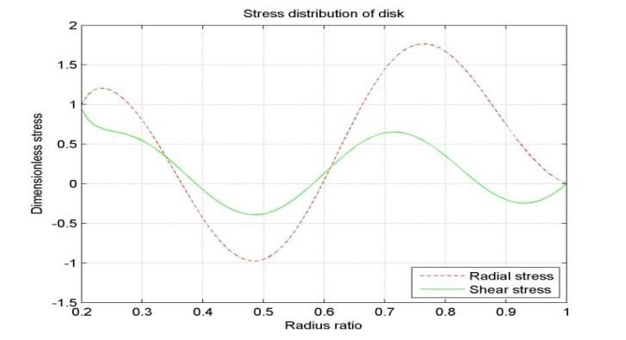

Single annular disk

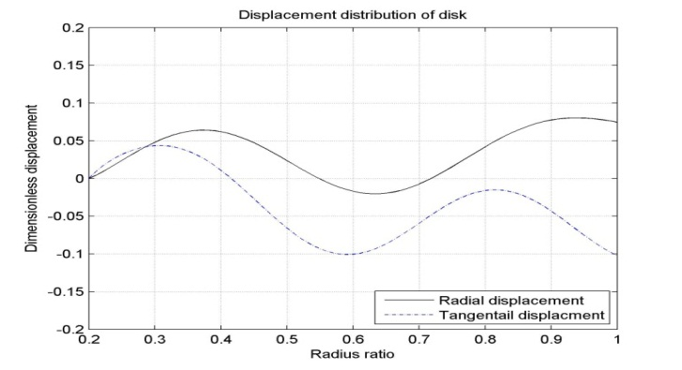

Single annular disk

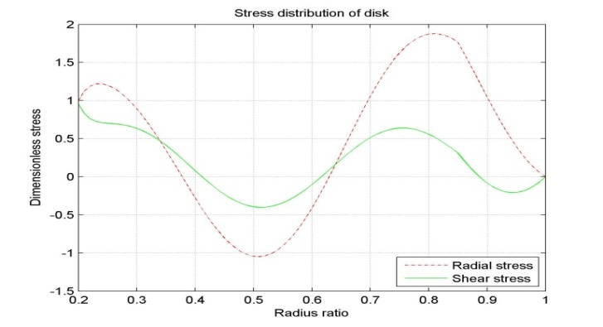

Add segment outside of disk

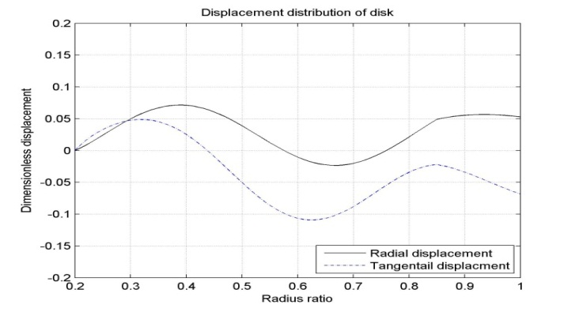

Add segment outside of disk

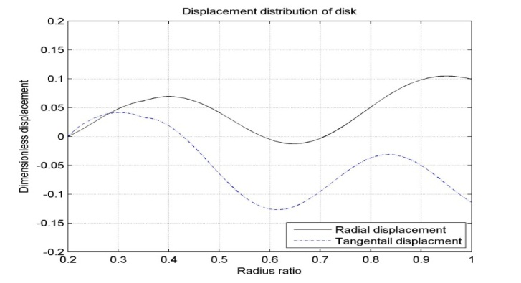

Add segment inside of disk

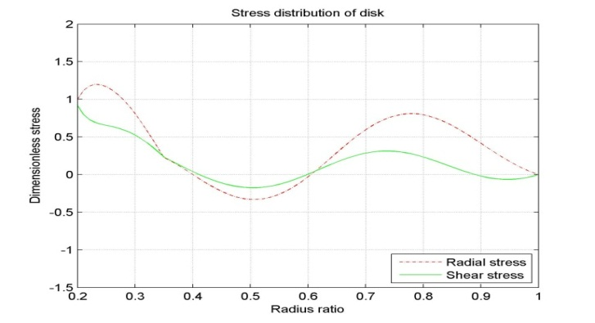

Add segment inside of disk

**Fig. 3** Distribution of non-dimensional modal displacements and stresses for a fixed-free rotating disk with or without embedded segment of steel at either inner or outer edge of the disk for , c/a = 0.2, 3, and

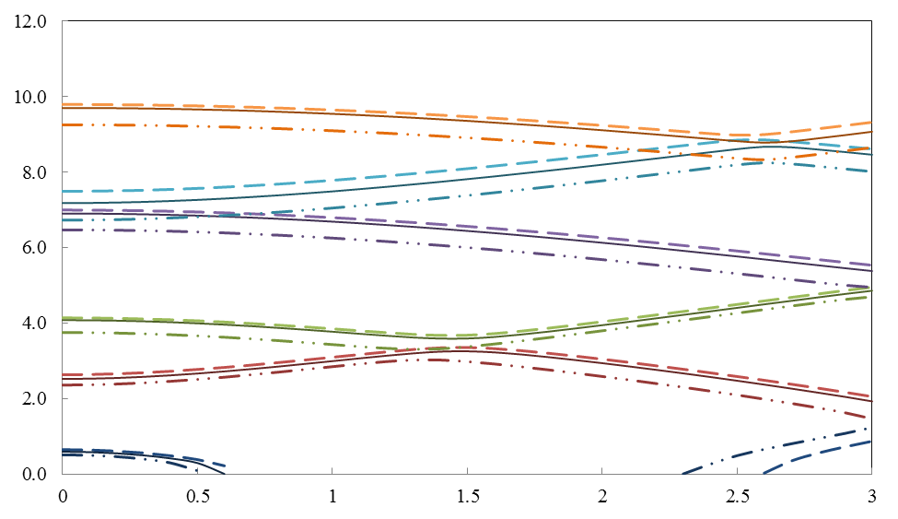

**Non-dimensional rotational speed,**

**Non-dimensional natural frequency,**

**(5,0)**

**(0,0)**

**(1,0)**

**(2,0)**

**(3,0)**

**(4,0)**

***t1* = 0.05**

***t2* = 0.05**

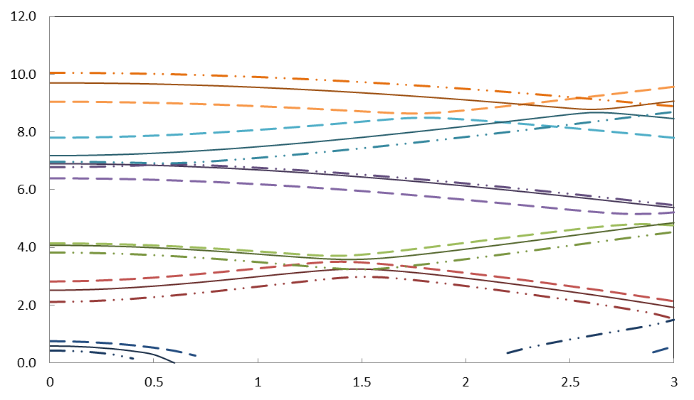

**Non-dimensional natural frequency,**

**Non-dimensional rotational speed,**

**(2,0)**

**(0,0)**

**(3,0)**

**(4,0)**

**(5,0)**

**(1,0)**

***t1* = 0.15**

***t2* = 0.15**

Single disk added segment at outer side added segment at inner side



**Fig.4** Non-dimensional natural frequencies versus dimensionless speed for a fixed-free rotating disks with/without added segment forand, and

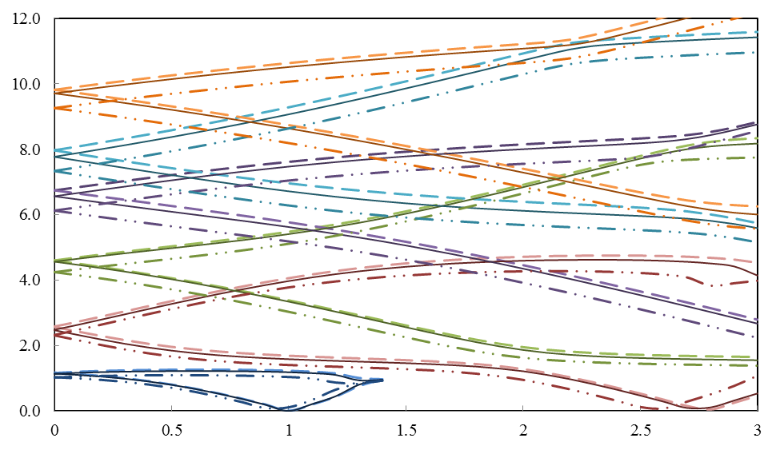

**Non-dimensional rotational speed,**

**Non-dimensional natural frequency,**

**(5,1)f**

**(0,1)b**

**(1,1)b**

**(1,1)f**

**(4,1)b**

**(4,1)f**

**(3,1)f**

**(2,1)f**

**(0,1)f**

**(5,1)b**

**(3,1)b**

**(2,1)b**

***t1* = 0.05**

***t2* = 0.05**

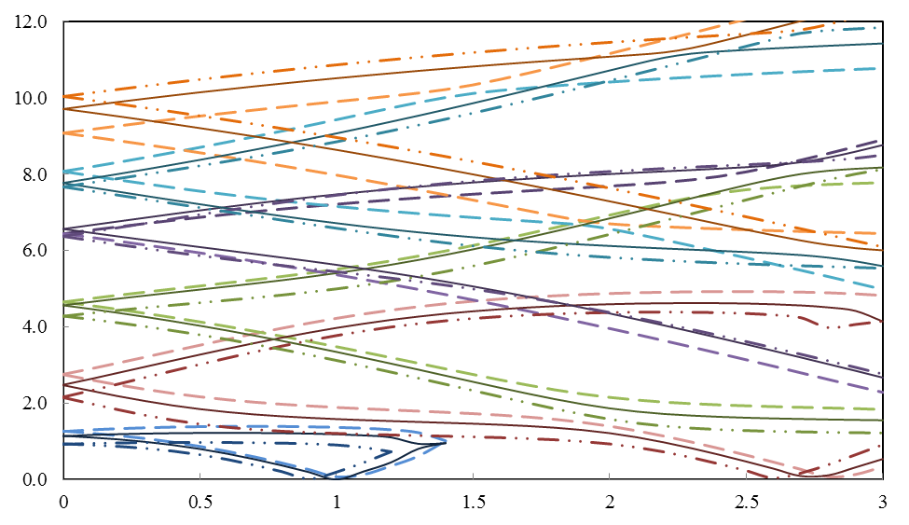

**Non-dimensional natural frequency,**

**Non-dimensional rotational speed,**

**(2,1)f**

**(0,1)f**

**(4,1)b**

**(4,1)f**

**(5,1)f**

**(1,1)f**

**(3,1)f**

**(1,1)b**

**(2,1)b**

**(5,1)b**

**(3,1)b**

**(0,1)b**

***t1* = 0.15**

***t2* = 0.15**

Single disk added segment at outer side added segment at inner side



**Fig.5** Non-dimensional natural frequencies versus dimensionless speed for a fixed-free rotating disks with/without added segment forand, and

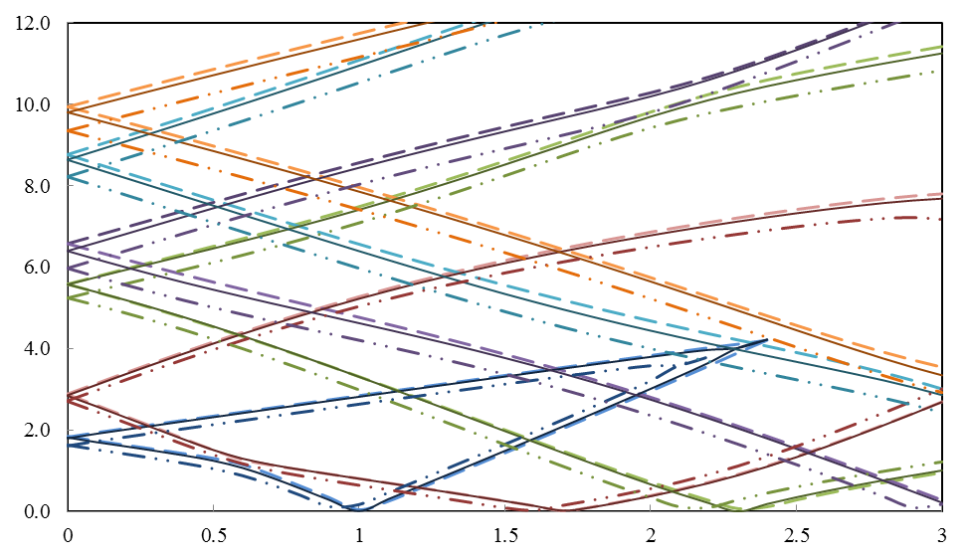

**Non-dimensional rotational speed,**

**Non-dimensional natural frequency,**

**(5,2)f**

**(0,2)b**

**(1,2)b**

**(1,2)f**

**(4,2)b**

**(4,2)f**

**(3,2)f**

**(2,2)f**

**(0,2)f**

**(5,2)b**

**(3,2)b**

**(2,2)b**

***t1* = 0.05**

***t2* = 0.05**

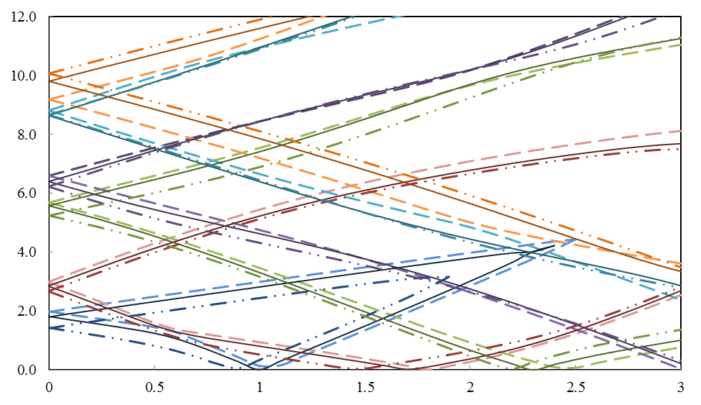

**Non-dimensional natural frequency,**

**Non-dimensional rotational speed,**

**(2,2)f**

**(0,2)f**

**(4,2)b**

**(4,2)f**

**(5,2)f**

**(1,2)f**

**(3,2)f**

**(1,2)b**

**(2,2)b**

**(5,2)b**

**(3,2)b**

**(0,2)b**

***t1* = 0.15**

***t2* = 0.15**

Single disk added segment at outer side added segment at inner side



**Fig.6** Non-dimensional natural frequencies versus dimensionless speed for a fixed-free rotating disks with/without added segment forand, and

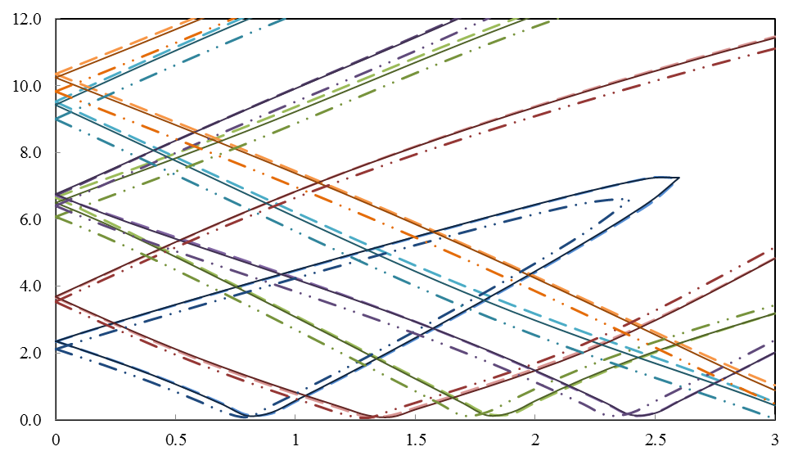

**Non-dimensional rotational speed,**

**Non-dimensional natural frequency,**

**(5,3)f**

**(0,3)b**

**(1,3)b**

**(1,3)f**

**(4,3)b**

**(4,3)f**

**(3,3)f**

**(2,3)f**

**(0,3)f**

**(5,3)b**

**(3,3)b**

**(2,3)b**

***t1* = 0.05**

***t2* = 0.05**

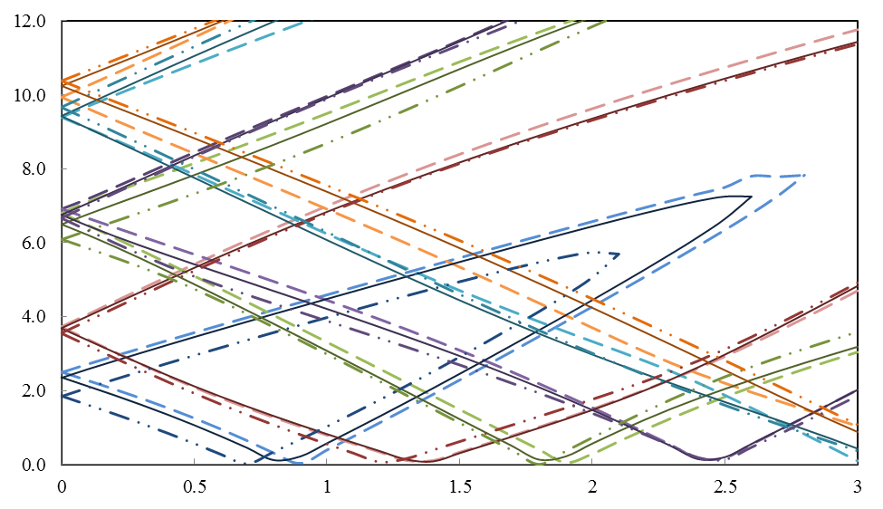

**Non-dimensional natural frequency,**

**Non-dimensional rotational speed,**

**(2,3)f**

**(0,3)f**

**(4,3)b**

**(4,3)f**

**(5,3)f**

**(1,3)f**

**(3,3)f**

**(1,3)b**

**(2,3)b**

**(5,3)b**

**(3,3)b**

**(0,3)b**

***t1* = 0.15**

***t2* = 0.15**

Single disk added segment at outer side added segment at inner side



**Fig.7** Non-dimensional natural frequencies versus dimensionless speed for a fixed-free rotating disks with/without added segment forand, and

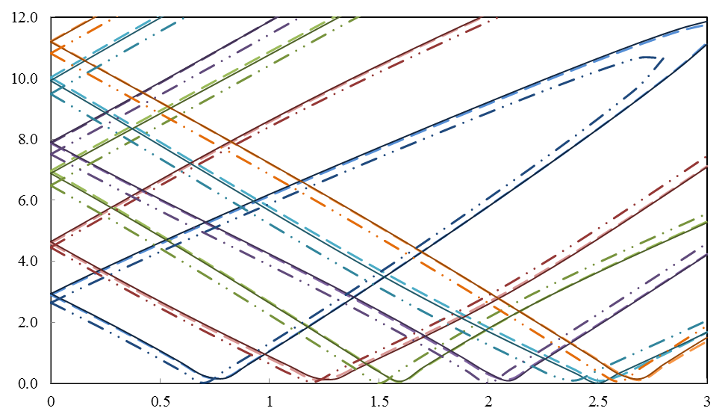

**Non-dimensional rotational speed,**

**Non-dimensional natural frequency,**

**(5,4)f**

**(0,4)b**

**(1,4)b**

**(1,4)f**

**(4,4)b**

**(4,4)f**

**(3,4)f**

**(2,4)f**

**(0,4)f**

**(5,4)b**

**(3,4)b**

**(2,4)b**

***t1* = 0.05**

***t2* = 0.05**

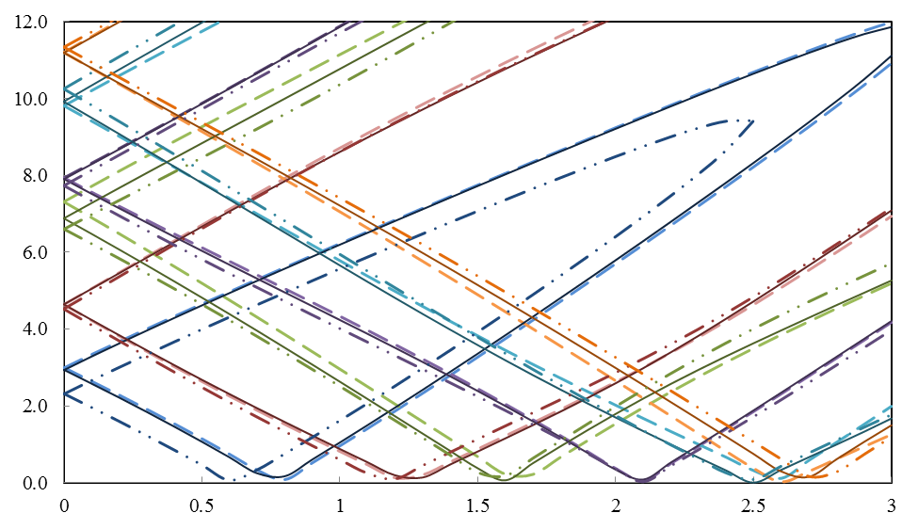

**Non-dimensional natural frequency,**

**Non-dimensional rotational speed,**

**(2,4)f**

**(0,4)f**

**(4,4)b**

**(4,4)f**

**(5,4)f**

**(1,4)f**

**(3,4)f**

**(1,4)b**

**(2,4)b**

**(5,4)b**

**(3,4)b**

**(0,4)b**

***t1* = 0.15**

***t2* = 0.15**

Single disk added segment at outer side added segment at inner side



**Fig.8** Non-dimensional natural frequencies versus dimensionless speed for a fixed-free rotating disks with/without added segment forand, and

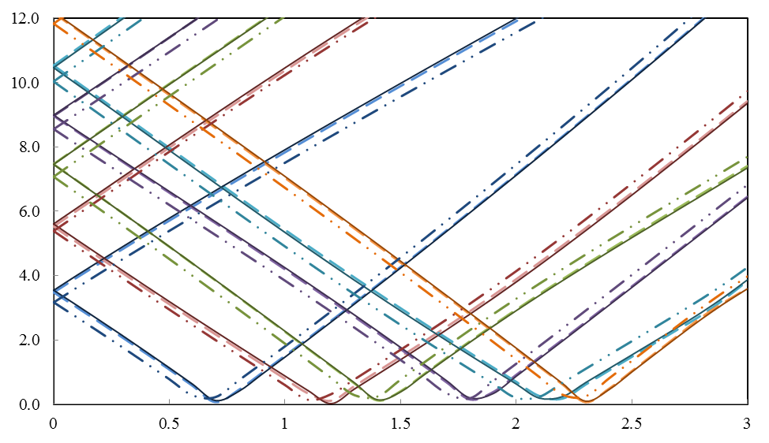

**Non-dimensional rotational speed,**

**Non-dimensional natural frequency,**

**(0,3)b**

**(1,3)b**

**(1,3)f**

**(4,3)b**

**(4,3)f**

**(3,3)f**

**(2,3)f**

**(0,3)f**

**(5,3)b**

**(3,3)b**

**(2,3)b**

***t1* = 0.05**

***t2* = 0.05**

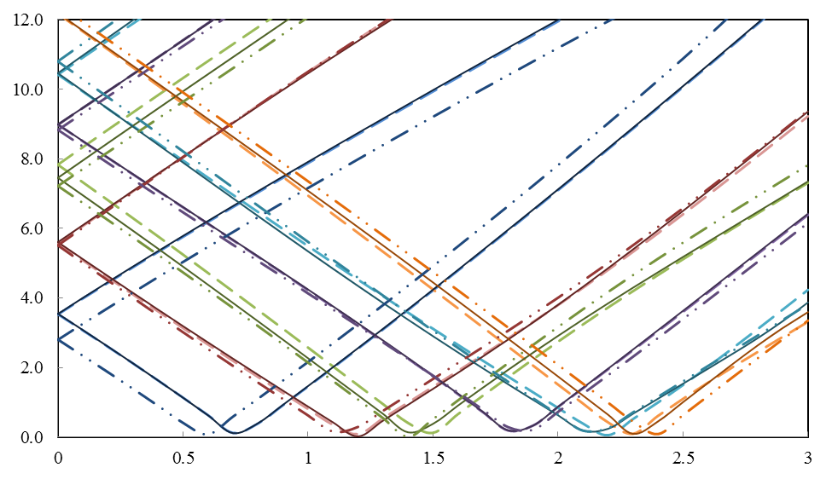

**Non-dimensional natural frequency,**

**Non-dimensional rotational speed,**

**(2,5)f**

**(0,5)f**

**(4,5)b**

**(4,5)f**

**(1,5)f**

**(3,5)f**

**(1,5)b**

**(2,5)b**

**(5,5)b**

**(3,5)b**

**(0,5)b**

***t1* = 0.15**

***t2* = 0.15**

Single disk added segment at outer side added segment at inner side



**Fig.9** Non-dimensional natural frequencies versus dimensionless speed for a fixed-free rotating disks with/without added segment forand, and

**5 Conclusions**

An analytical method is presented to determined natural frequencies, modal stresses and displacements for linear in-plane free vibration of the double-segment rotating annular disk with material discontinuity. This modals information can be computed for any number of modal diameters and a number of nodal circles for a wide range of rotating speeds. The presented technique can also provide a design guideline to ensure selecting appropriate geometry and material properties to avoid undesirable critical speeds and/or resonances for any range of required operating speed. The computed results demonstrate that the effect of rotational speed on natural frequency depended on the radius ratio, the mode of vibration, as well as, the material properties for each segment of the compound disk. Furthermore, it was concluded that with an attachment of a small segment of material with higher density and higher modulus of elasticity around the inner side of rotating an annular disk, natural frequencies would be increased.

**References**

[1] Bhuta, P. G. and Jones, J. P. (1963), Symmetric planar vibrations of a rotating disk, *Journal of the Acoustical Society of America*, **35**(7), 982-989.

[2] Burdess, J. S., Wren, T. and Fawcett, J. N. (1987), Plane stress vibrations in rotating disks, *Proceedings of Institute of Mechanical Engineers*, **201**, 37-44.

[3] Chen, J. S. and Jhu, J. L. (1996), On the in-plane vibration and stability of a spinning annular disk, *Journal of Sound and Vibration*, **195**, no. 4, 585–593.

[4] Hamidzadeh, H. R. (1998), Linear in-plane vibration of high speed rotating disks, *Proceedings of the International Symposium on Impact and Friction of Solids, Structures and Intelligent Machines*, Ottawa, Canada.

[5] Hamidzadeh, H. R. and Dehgani, M. (1999), Linear in-plane free vibration of rotating disks, *Proceedings of the ASME 17th Biennial Conference on Mechanical Vibration and Noise*, DETC **99/**VIB-8146

**[**6] Hamidzadeh, H. R. (2000), Free vibration of rotating ring - an analytical solution, *ASME International Mechanical Engineering Congress and Exposition*, DE **108**, 9-16.

[7] Hamidzadeh, H. R. and Karim, R. U. (2001), In-plane free vibrations of the double – segment compound rotating disk, *ASME International Mechanical Engineering Congress and Exposition*, DE 111, 169-173

# [8] Hamidzadeh, H. R (2002), In-plane free vibration and stability of rotating annular disks, *Journal of Multi-body Dynamics*, 216, 371-380.

[9] Deshpande, M., and Mote, C. D. (2003), In-plane vibration of thin disks, *ASME J. Vib. Acoustic*, **125**, 68-72.

1. † Corresponding author.

   Email address: [esarfara@my.tnstate.edu](mailto:esarfara@my.tnstate.edu), [hhamidzadeh@tnstate.edu](mailto:hhamidzadeh@tnstate.edu)